|  |
| --- |
| Bayer Healthcare |
| Doc41 Web UI User Manual |
|  |
|  |
| **Ingo Kaulbach (Bayer Business Services GmbH)** |
| **27.01.2014** |

|  |
| --- |
|  |

|  |  |
| --- | --- |
| Infobox |  |
| Applicable System: | External Access: Doc41 Web UI |
| Title: | User Manual |
| Author: | Ingo Kaulbach (EVFPU) |
| Change history (version number, last change, changed by, date) | 1. Ingo Kaulbach EVFPU, 2014-01-27, initial setup |
| Current Version of document: | 1.0 |
|  |  |

Content

User Guide 3

Login 3

Login screen 3

My Profile 4

Upload 5

Download 6

Roles 7

Carrier 7

Customs Broker 15

Material Supplier 16

Product Supplier 17

ViewerCountry 18

ViewerCustomer 19

Layout Supplier 20

PM supplier 23

Administrator Guide 26

User management 26

Overview 26

Create Bayer internal user 27

Create external user 28

Edit User 30

Internal 30

External 30

# User Guide

## Login

### Login screen

Open   
<https://doc41.bayer.com/>   
in your browser and enter your user id and password if you are already registered.

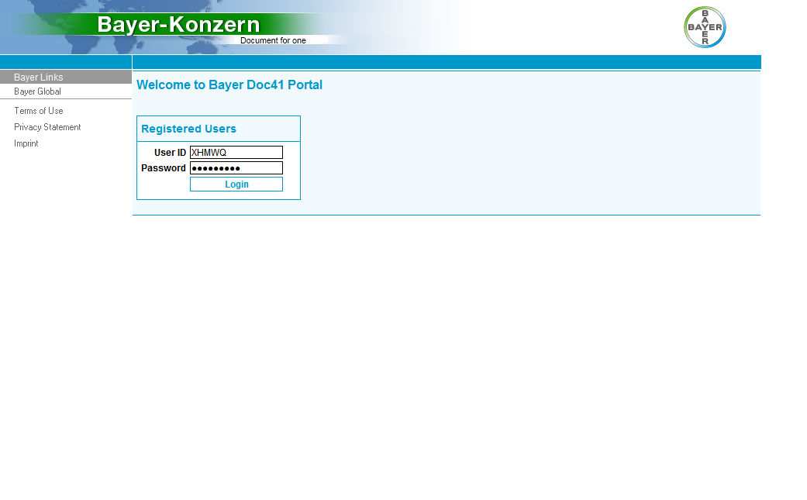

## My Profile

After you have successfully logged in, you will see the “My Profile”-page, where you can find all details of your profile.

You can see your personal details, like first- and surename, cwid, email-address and language.

You can see the roles assigned to your account.

You can also see the partner numbers, countries and plants assigned to your account.

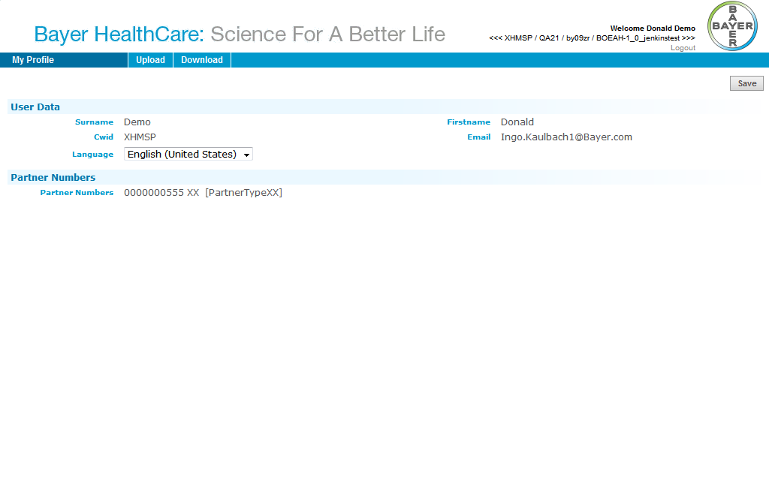

## Upload

If you have a role that allows you to upload a document you will find the Upload-tab in your top navigation menu.

Depending on your roles you will find the types of documents you can upload, for example *Bill of Lading*.

In section Roles you will find which documents you can upload for a certain role.

## Download

If you have a role that allows you to download a document you will find the Download-tab in your top navigation menu.

Depending on your roles you will find the types of documents you can download, for example *Bill of Lading*.

In section Roles you will find which documents you can download for a certain role.

## Roles

### Carrier

#### Download: Air waybill

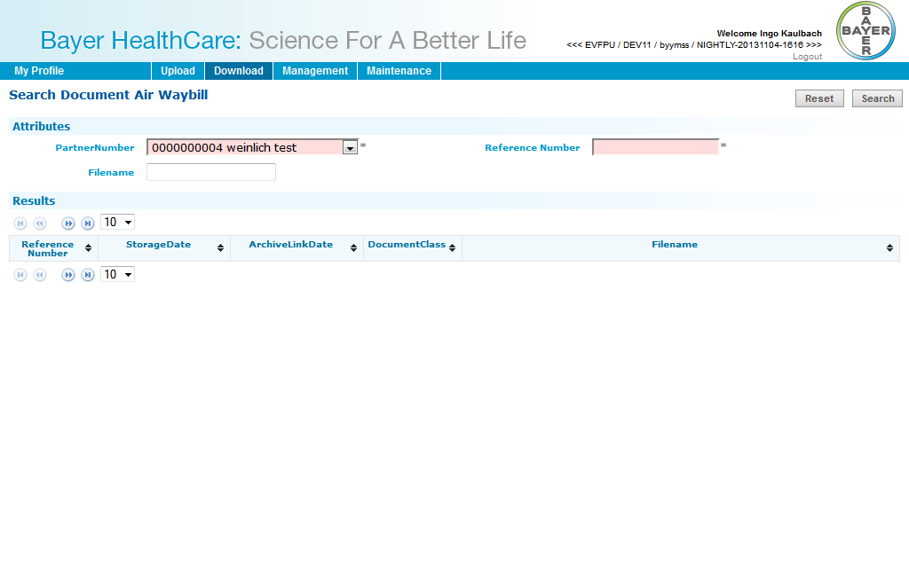

#### Download: Bill of Lading

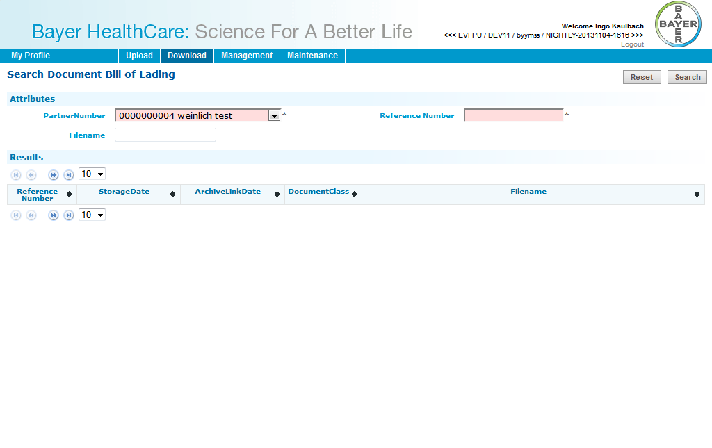

#### Download: Shippers declaration

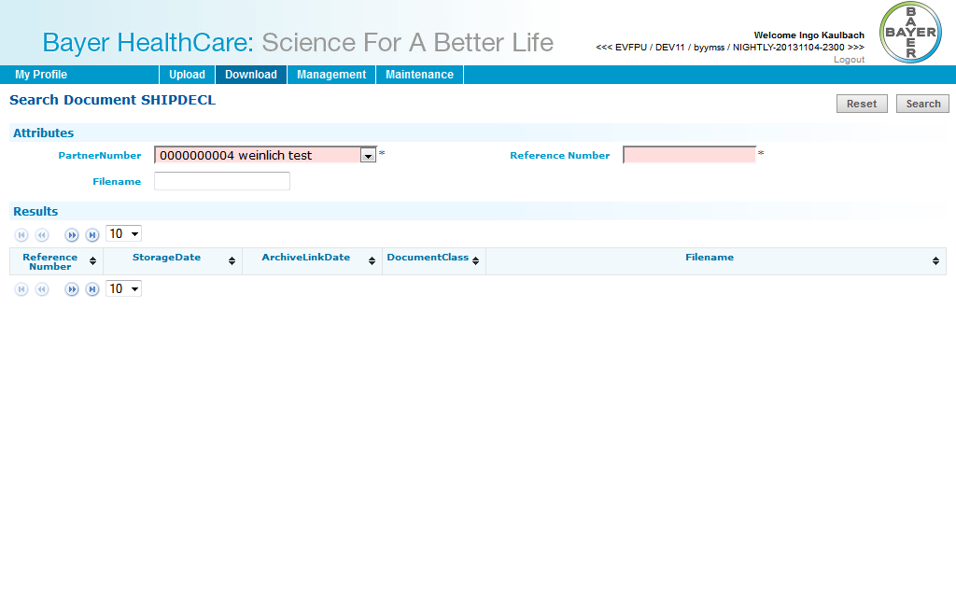

#### Download: Waybill

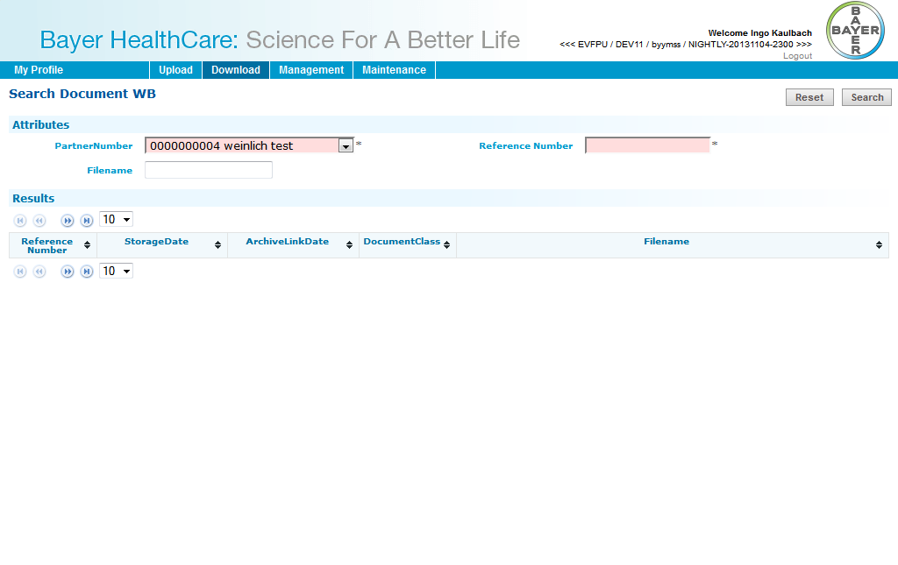

#### Download: FDA certificate

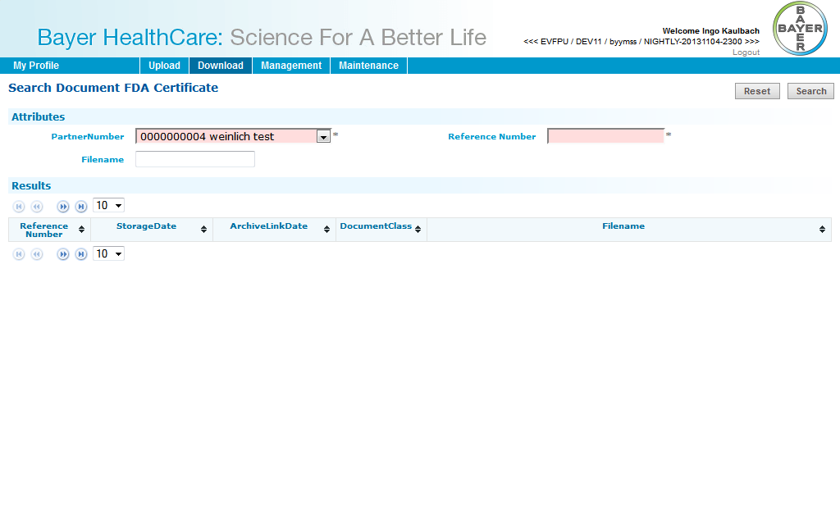

#### Download: CMR (outgoing)

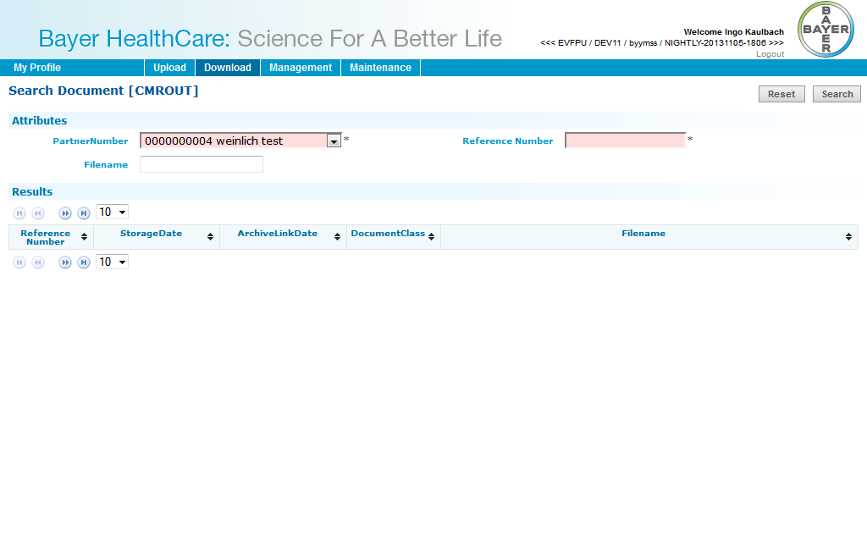

#### Upload: CMR (incoming)

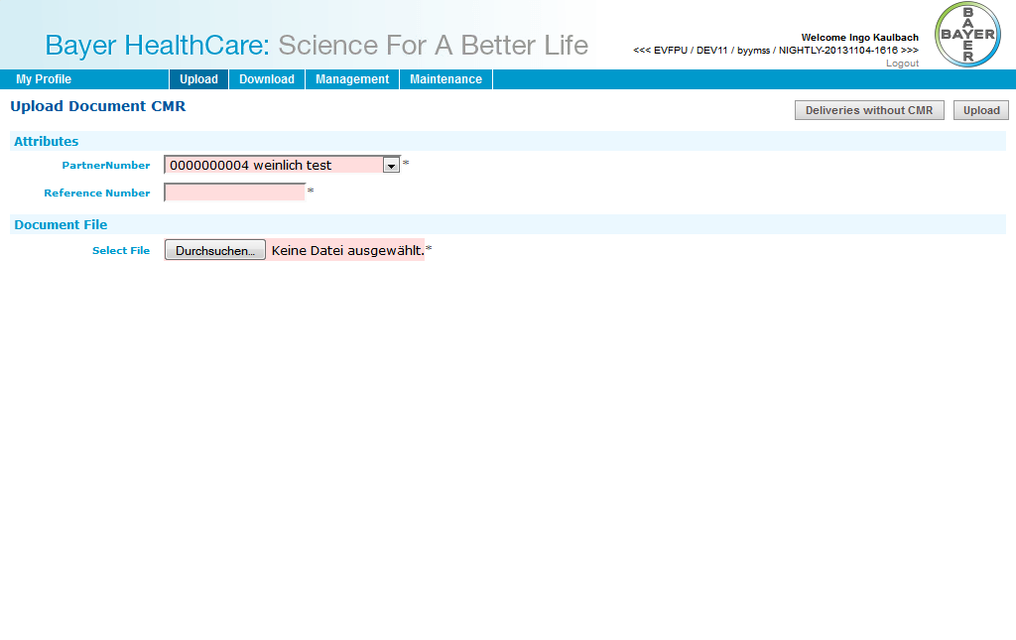

#### Upload: Air waybill

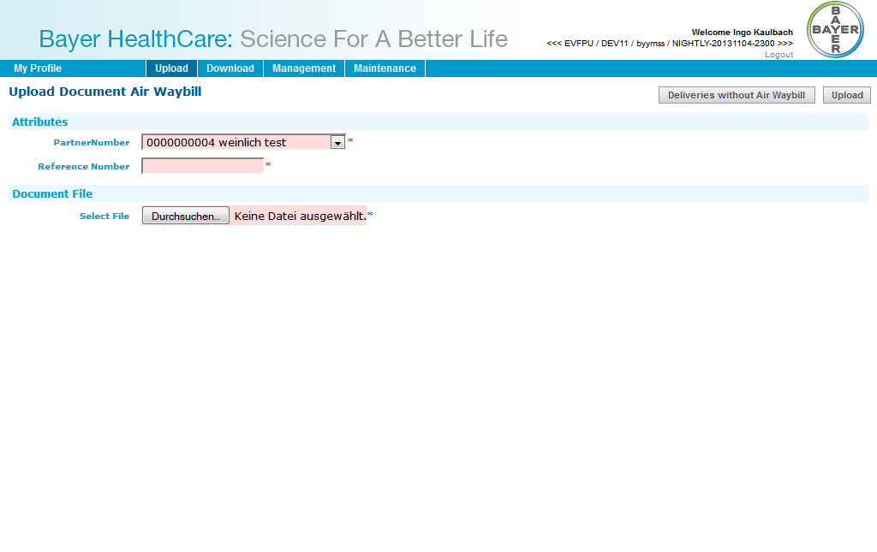

#### Upload: Bill of Lading

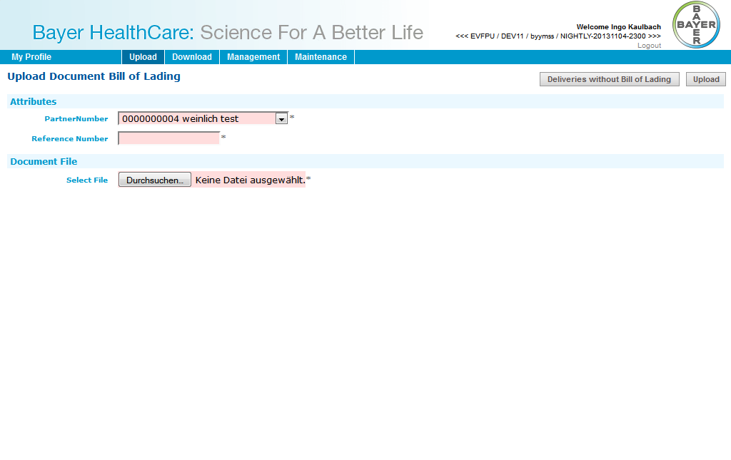

### Customs Broker

#### DirectDownload: Air waybill

You will receive a direct link to the document. After clicking on the link you have to login with your username and password. You can download the document directly than.

#### DirectDownload: Bill of Lading

You will receive a direct link to the document. After clicking on the link you have to login with your username and password. You can download the document directly than.

#### DirectDownload: Shippers declaration

You will receive a direct link to the document. After clicking on the link you have to login with your username and password. You can download the document directly than.

#### DirectDownload: Waybill

You will receive a direct link to the document. After clicking on the link you have to login with your username and password. You can download the document directly than.

#### DirectDownload: FDA certificate

You will receive a direct link to the document. After clicking on the link you have to login with your username and password. You can download the document directly than.

### Material Supplier

#### Upload: Supplier CoA

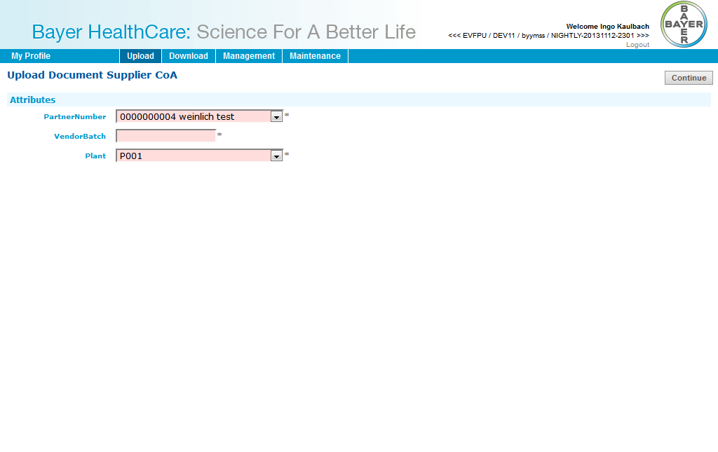

### Product Supplier

#### Upload: Delivery Certificate

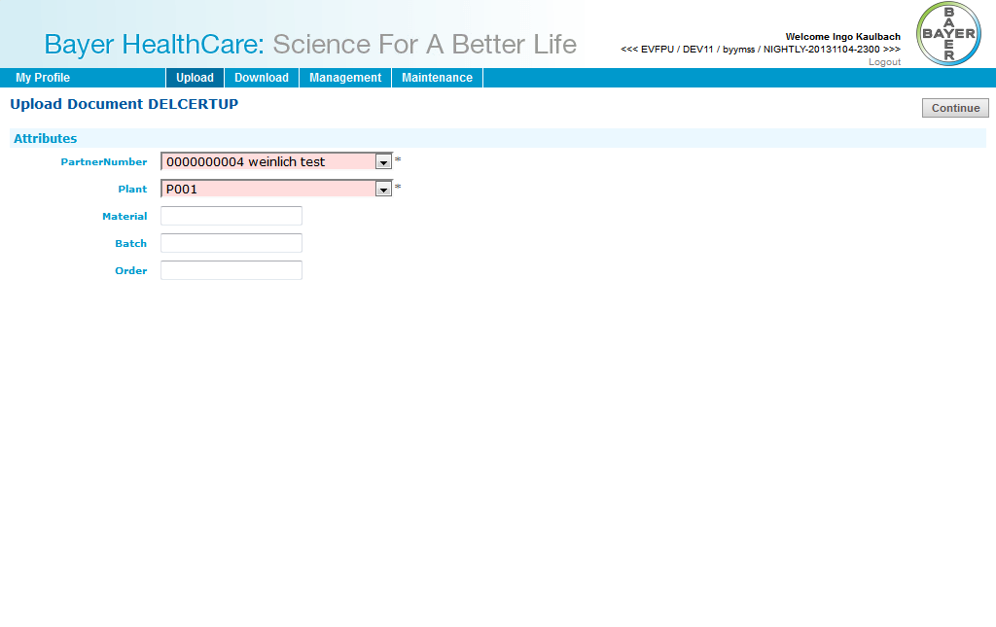

### ViewerCountry

#### Download: Delivery Certificate

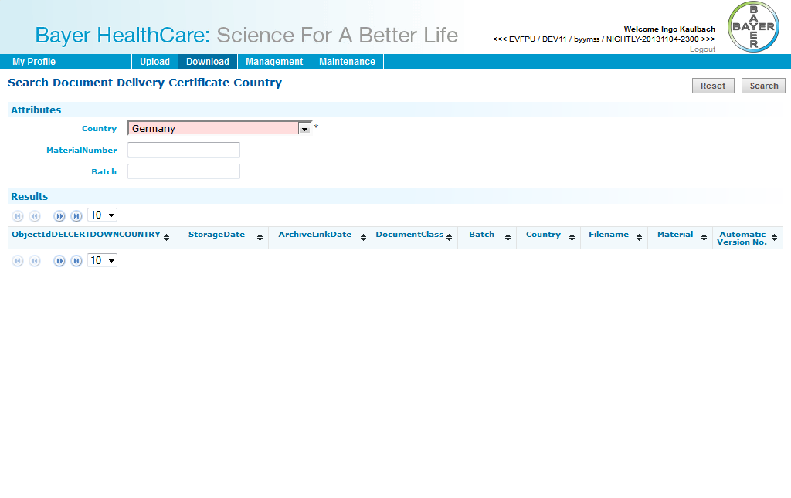

### ViewerCustomer

#### Download: Delivery Certificate

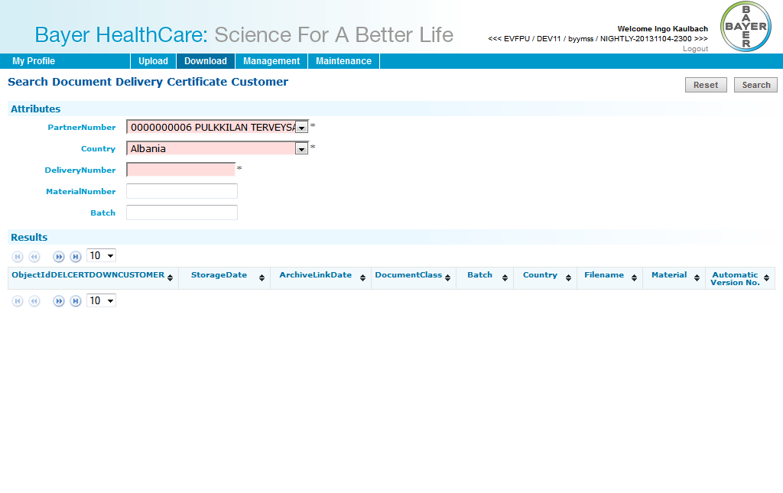

### Layout Supplier

#### Download: HighRes Layout

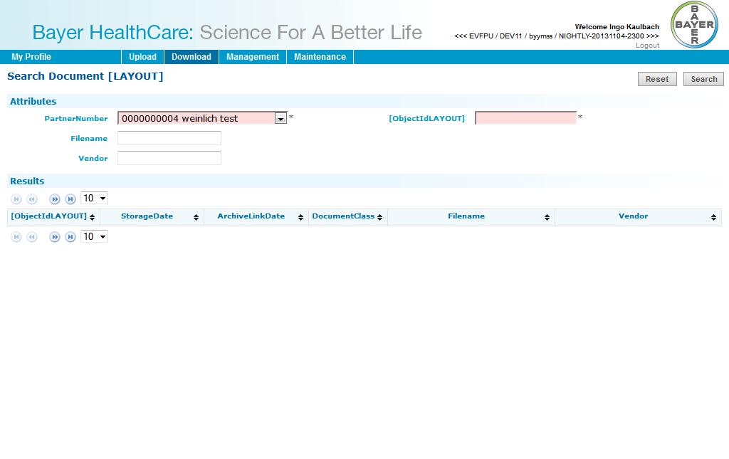

#### Download: LowRes Artwork

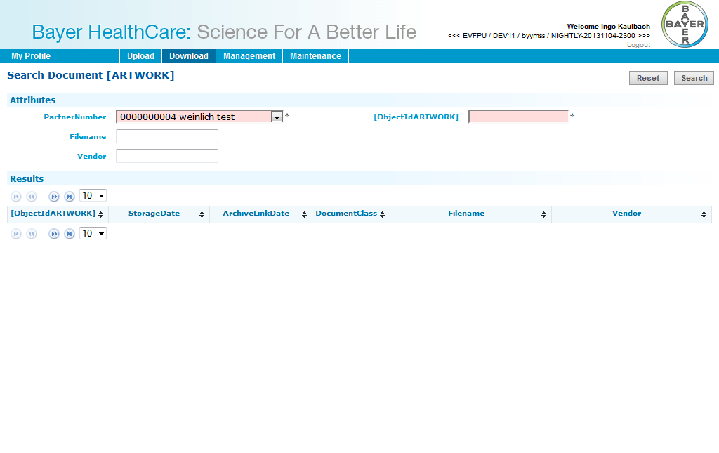

#### Upload: HighRes Layout

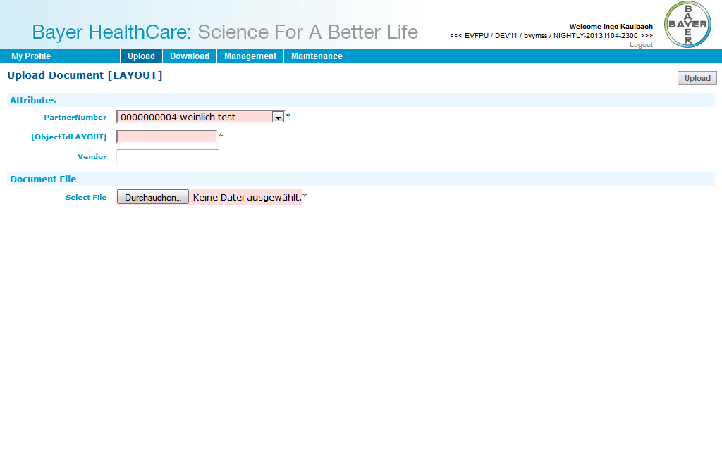

### PM supplier

#### Download: Packaging specification

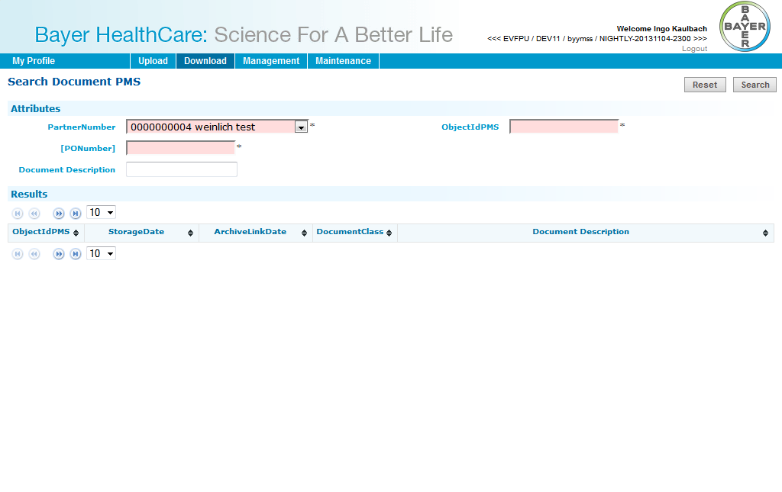

#### Download: Technical drawing

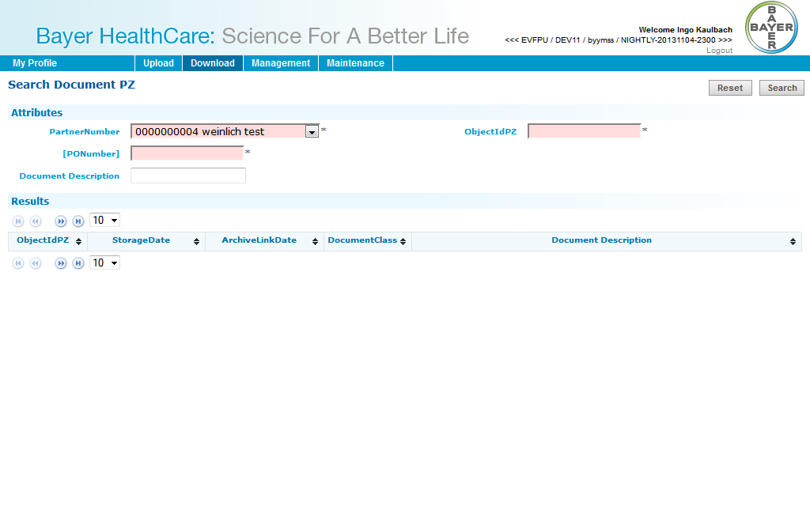

#### Download: Technical packaging and Delivery requirements

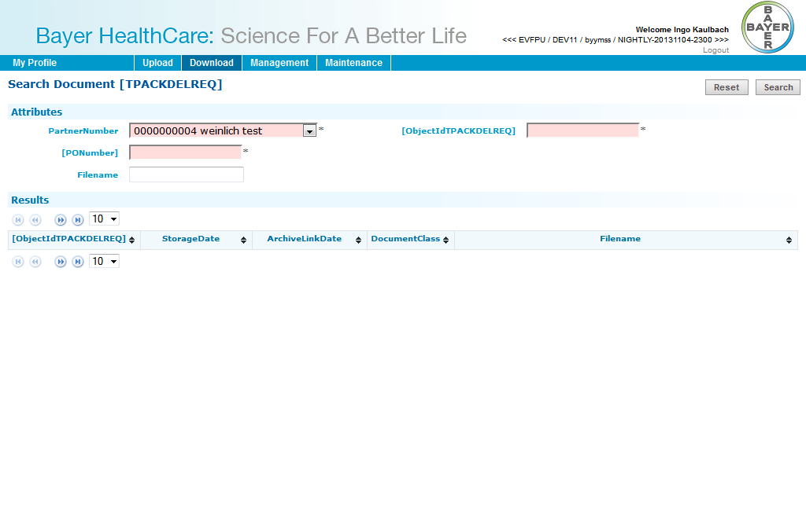

#### Download: CMR (outgoing)



# Administrator Guide

## User management

### Overview

This screen shows an overview of all users.

The users can be filtered by entering values in the header filter fields.  
The users can be sorted by clicking on the in the header fields.

The first icon indicates the status of the user: green for active, red for inactive. This status can be toggled by clicking the red/green icon in the last column. The icon in the second to last column opens the edit dialog.

There are two buttons to create an internal or external user.

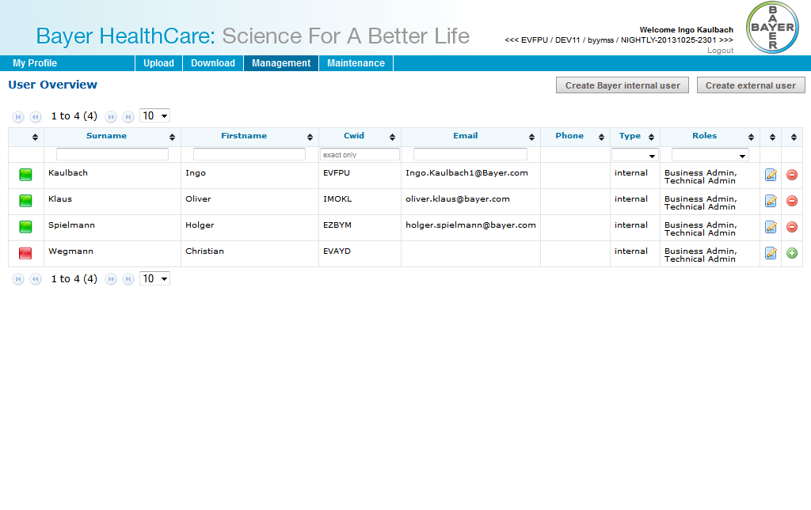

### Create Bayer internal user

This screen is used for importing internal (=Bayer) users into the system. After a CWID is inserted and “Create Bayer internal user” is clicked, the Import Screen will be shown.

Time zone, language and status of the user have to be set. Only active users can log into Doc41WebUI.

An internal user can have following roles:

* Business Admin
* Technical Admin
* *Observer*

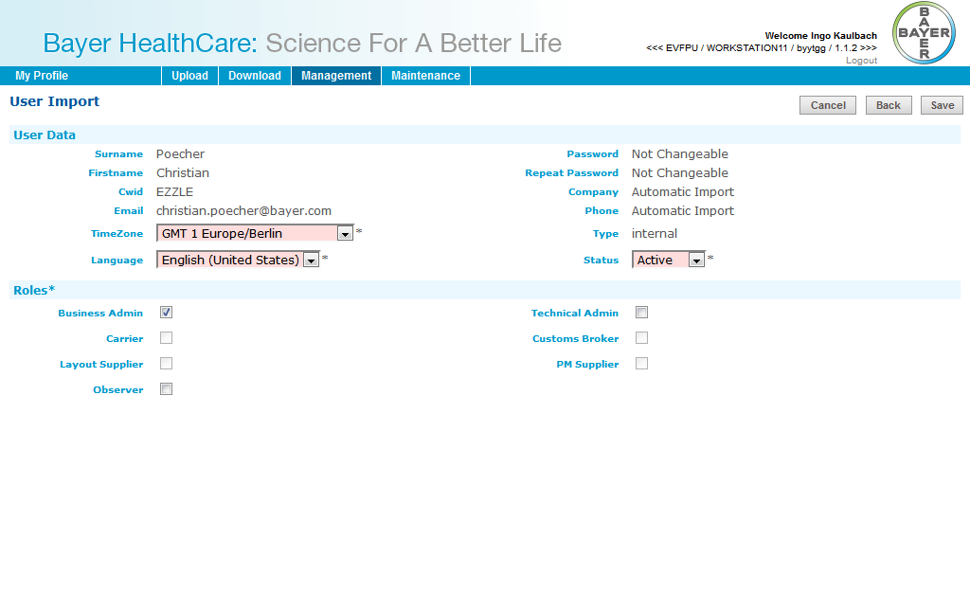

Cancel will go back to user overview.  
Back will go back to enter another CWID.  
Save will create the user.

### Create external user

This screen is used for creating external users into the system.   
For external users First-, Surname, Email-Address and Password must be entered.

Time zone, language and status of the user have to be set. Only active users can log into Doc41WebUI.

An external user can have following roles:

* Carrier
* Customs Broker
* Material Supplier
* Product Supplier
* Viewer Country
* Viewer Customer
* Layout Supplier
* PM Supplier
* *Observer*

An external user can have Partner Numbers, Countries and Plants.  
Partner Numbers are only numbers (no letters etc.). After click on “Add”-button the partner will be searched in SAP and added to list, if found.  
Countries can be added from a list.  
Plants can be added as text. A Plant must only have numbers and upper case letters and a maximum length of 4.

Cancel will go back to user overview.  
Save will create the user.

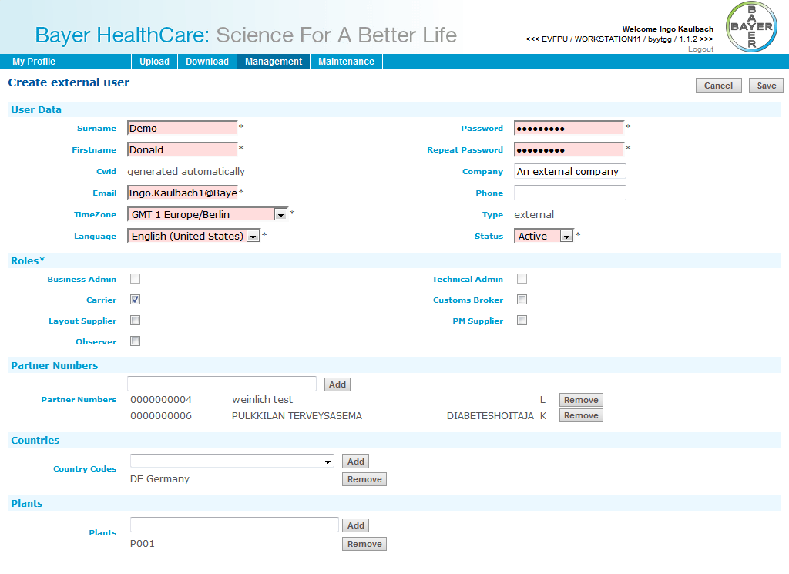

## Edit User

This dialog is used for existing internal/external users. It looks like the User Import or Create external user dialog.

### Internal

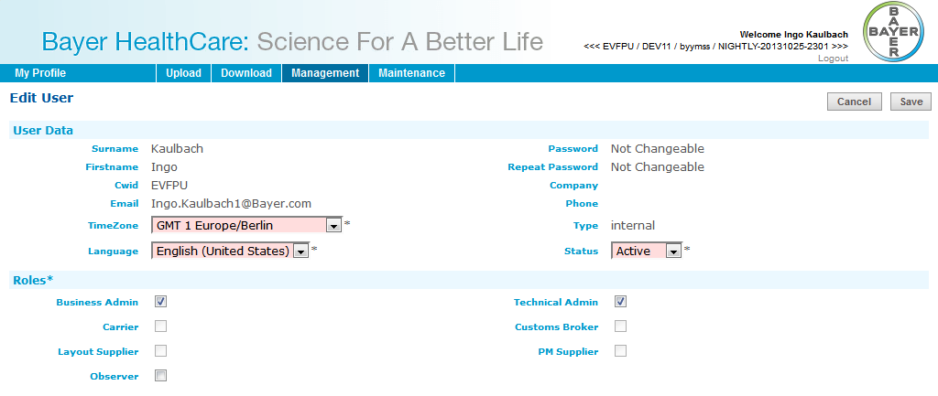

### External

